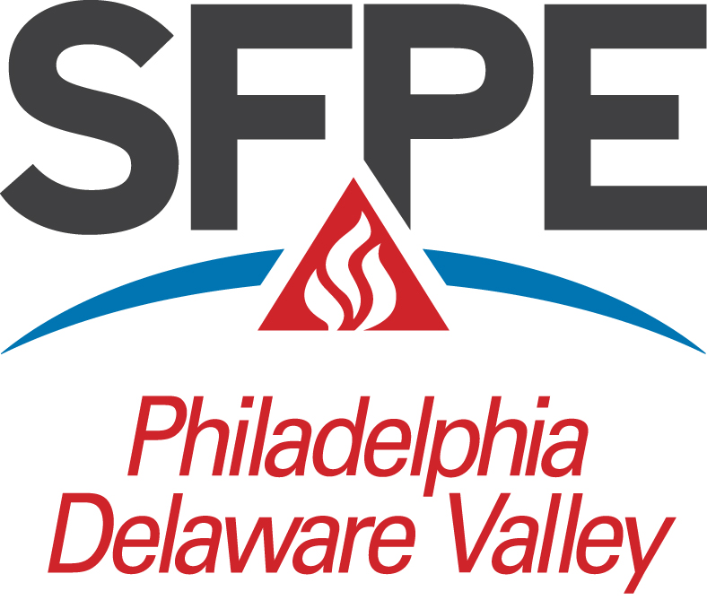

Application for 2021/2022

John D. Cook III and Philip L. Gaughan Scholarships

Must be received by Monday, April 4, 2022

(Please fill in using Microsoft Word)

- To be completed by the Applicant (Use additional sheets as required)
  - Name:
  - Mailing Address:
City: State: Zip:
  - Telephone Number:
  - Email Address:
  - Eligibility Requirements:
    - Home address where permanent scholarship area residence is established, if different from mailing address above. Give dates living at each address:
Home Address:
City: State: Zip:
    - Years at Permanent Residence:
    - Program of Study:
    - Institution:
Address:
City: State: Zip:
    - Full-time status (Undergraduate-12 credit hours/semester; Graduate-9 credit hours/semester minimum). Please indicate your status at the end of the 2020 Fall Semester:
    - 4-5 year Undergraduate/Graduate Student:
Sophomore Junior Senior Graduate
      - 2 Year Fire Protection Engineering/Fire Science Student
Freshman (2nd semester) Other (explain)
  - Please address the following in a letter of introduction attached to this application:
    - When did you first become interested in pursuing a career in the field of Fire Protection or Allied Field? Please indicate the circumstances behind this decision.
    - Please list and briefly explain, in order of your perceived importance, any past experience and/or accomplishments that you feel will make you competent in the Fire Protection Engineering or Allied Field. Your response is not limited strictly to fire protection-related interests or activities.

    - What are your goals, both short-term and long-term?

  - Enclose with this application:
    - Letter of Introduction as outlined above.
    - Complete academic transcripts of all undergraduate and graduate programs.
    - Proof of Residence in the defined scholarship geographic area. Examples of proof of residence include copy of driver’s license, current utility bills, redacted tax return, and voter’s registration card.
    - Any additional supporting evidence or relevant information that, in your opinion, the Committee can use in evaluating your application.
  - To the best of my knowledge, I meet all eligibility requirements for scholarship consideration and attest that the information submitted herein is both true and accurate.

Signature: Date:

IMPORTANT
After completing this application, please forward this scholarship application package with all supporting documentation to your School Advisor or Program Chairperson for a letter of recommendation.

- To be completed by the Program Chairperson or Advisor and mailed or emailed directly to the Scholarship Committee Chairman.
In the space provided, please discuss why you consider this individual deserving of a John D. Cook III Scholarship or Philip L. Gaughan Award. If you prefer, a separate Letter of Recommendation is acceptable.

Name: Title:
Signature: Date:

Upon completion please send the entire application package electronically (in PDF format) to jay.stough@verizon.net on or before April 4, 2022.

Electronic version preferred.

- For Committee Use

Status | x | Date
Received
Acknowledged
Accepted
Notified
Plaque Obtained
Check Cut
Home Newspaper Notified

Criteria and Information for Scholarship Consideration

The following criteria and information provides guidance in the submission of applications for a John D. Cook III and Philip L. Gaughan Scholarship offered by the Philadelphia-Delaware Valley Chapter (PDVC) of the Society of Fire Protection Engineers (SFPE).

Residency:

Applicant must be or have been a native or resident of the scholarship geographic area served by the PDVC. Resident is defined as a person having lived the last four years in the Chapter area. Provide address or addresses and dates living at each address. Applicant must also be an American Citizen or legal resident.

The area includes:

Counties in Pennsylvania: Adams, Berks, Bradford, Bucks, Carbon, Centre, Chester, Clinton, Columbia, Cumberland, Dauphin, Delaware, Franklin, Juniata, Lackawanna, Lancaster, Lebanon, Lehigh, Luzerne, Lycoming, Mifflin, Monroe, Montgomery, Montour, Northumberland, Northampton, Perry, Philadelphia, Pike, Schuylkill, Snyder, Sullivan, Susquehanna, Tioga, Union, Wayne, Wyoming, and York.

Counties in New Jersey: Atlantic, Burlington, Camden, Cape May, Cumberland, Gloucester, Mercer, Ocean, and Salem.

All of Delaware.

Academic Performance:

Applicant must have maintained a minimum 2.5 (4.0 scale) cumulative average or equivalent for college studies to date. Copies of Transcripts are required.

Program of Study:

Applicant must have full-time status (Undergraduate-12 credit hours/semester; Graduate-9 credit hours/semester) and in the 2021-2022 school year be enrolled in one of the following:

- An ABET accredited 4 year Fire Protection Engineering Program and shall have completed three (3) semesters of study by the end of the first semester of the 2021-2022 school year, or
- An accredited 4 year Engineering or Architectural Program and shall have attained Sophomore standing or equivalent by the end of the first semester of the 2021-2022 school year, and can demonstrate a serious interest in a Fire Protection Engineering career, or
- A Graduate Engineering Program, with related studies in Fire Protection approved by the Committee, or
- A 4 year Fire Protection Engineering/Fire Science Program approved by the Committee and shall have attained Sophomore status or equivalent by the end of the first semester of the 2021-2022 school year, and can demonstrate serious interest in a Fire Protection Engineering career, or
- A 2 year Fire Protection Engineering/Fire Science Program approved by the Committee and shall have completed one semester or equivalent by the end of the first semester of the 2021-2022 school year, and can demonstrate serious interest in a Fire Protection Engineering career.

In the case where a student meets enrollment criterion, the demonstration of serious interest in a Fire Protection Engineering career shall be left to the applicant, but may include: college courses involving fire protection, extracurricular activities, recommendations of professors and professional mentors, attendance at the extracurricular fire protection seminars, and/or membership in a fire department or similar professional organization devoted to fire safety. The level of commitment shall be assessed by the Committee on a case-by-case basis.

Any of these programs, 2 year, undergraduate and graduate curriculums could provide education for a career in Fire Protection Engineering.

The John D. Cook III and Philip L. Gaughan Scholarships are awarded without regard to race, color, creed, ethnic background, gender or physical capabilities.

