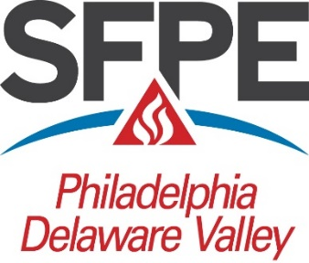

Society of Fire Protection Engineers Philadelphia-Delaware Valley Chapter

The Scholarship Committee of the Philadelphia-Delaware Valley Chapter of the Society of Fire Protection Engineers is pleased to announce its offering of scholarships for the 2022-2023 academic year. We are seeking candidates for consideration to receive awards from the John D. Cook III and Philip L. Gaughan Scholarship Funds, for demonstrated academic achievement. In the past, scholarship awards ranging from $500.00 to $2,500.00 have been awarded. More than one scholarship may be awarded, depending on the number and quality of applications received. This past year three scholarships were awarded, 2 for $2500 and 1 for $1000.

The purpose of these scholarships is to promote the science and practice of Fire Protection Engineering and its allied fields. Students need not be enrolled in a fire protection engineering degree program but may be in an allied engineering, architectural or science program and demonstrate an interest in fire protection. The scholarship will be awarded for demonstrated academic achievement and performance in the field of fire protection.

Candidates must be full-time students and have attained at least sophomore class standing or have completed at least one semester of study in a two-year program as of the end of the fall semester, 2022 and demonstrate a serious interest in a career in fire protection or its allied fields, and shall be a resident of one of the areas described in the Criteria and Information Sheet attached to the scholarship application.

Applicants should submit a copy of the enclosed application form, a full official transcript (including course load for the current semester), and a letter of introduction that outlines their qualifications for this scholarship and any other information they feel would help committee members in their selection. Proof of permanent residence in the scholarship area is an eligibility requirement. Submission of such evidence will be left to the discretion of each applicant; each case will be evaluated during the selection process. If there are any questions regarding a student’s eligibility for this scholarship, they are encouraged to submit an application. They may also contact the Scholarship Committee by telephone at the number listed below.

Completed applications must be received by MARCH 1, 2023. No applications will be accepted after this date.

Scholarship winners will be contacted by telephone or email and the awards will be presented at the May 2023 meeting of the Philadelphia-Delaware Valley Chapter of the SFPE. 2
Please copy the enclosed Application Form and the Criteria and Information for Scholarship Consideration for distribution to all students who wish to apply for the John D. Cook III Scholarship or Philip L. Gaughan Scholarship. This form will also be available on our Chapter website at www.sfpephiladelphia.org/. The PDF version of the application form contains fields that may be used to fill in applicant general information. Please type or print legibly.

Please contact Mr. Jay Stough, Scholarship Committee Chair at 215-917-3684 during normal business hours if there are any questions concerning completion of the applications. He may also be reached via email at jay.stough@verizon.net

Download the PDF version of the Application | Download the Word version of the Application

