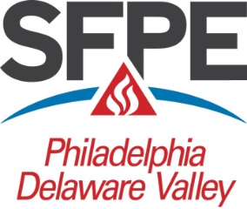
2024 Seminar & Trade Show
Speaker Schedule
Session 1
8:00 – 9:00
Room “A” • Todd Iaeger, U.L.: An overview of fire alarm certification per NFPA 72-Chapter 26
Room “B” • Garth Dehoff, Honeywell: Emergency Responder Radio Communication Systems (ERRCS)
Session 2 9:05 – 10:05
Room “A” • Michael Joanis, NFSA: “NFSA’s Top 10 Fire Pump Questions and Responses”
Room “B” • Todd Stevens/Illy Logu, IFP: Advancing Fire Safety toward Decarbonization and Environmental Sustainability.
Break 10:10 – 10:50 Please visit the vendors in Exhibit Hall
Session 3 10:50 – 11:50
Room “A” • Keynote Speaker: Pennsylvania State Fire Commissioner Thomas Cook
Lunch 11:50 – 1:15 Please visit the vendors in Exhibit Hall
Session 4 1:15 – 2:15
Room “A” • Jerry Back, Jensen Hughes: NFPA 855 Overview Lithium Battery Update
Room “B” • Rebecca Bowman, Senior Director National Society of Professional Engineers: Ethics and Professional Practices.
Session 5 2:20 – 3:20
Room “A” • Kevin Hall, AFSA: Evaluations of Existing Sprinkler Systems
Room “B” • Rick Seidel, Fike: Update New Technology to Stop Thermal Runaway
Session 6 3:25 – 4:25
Room “A” • Pat Dixon, Perimeter Solutions: Overview of AFFF to SFFF Transition Considerations.
Room “B” • Bill Flanagan, Jacobs: Smoke Modeling for Lithium Batteries.

